‘Let’s be Creative’ Progression Online Summer Schools 2021
Creative activities for all ages
Draw, Sculpt, Sing & Digital Art

Primary School
Pre-16 years
Over 16 Years
Mature Learners

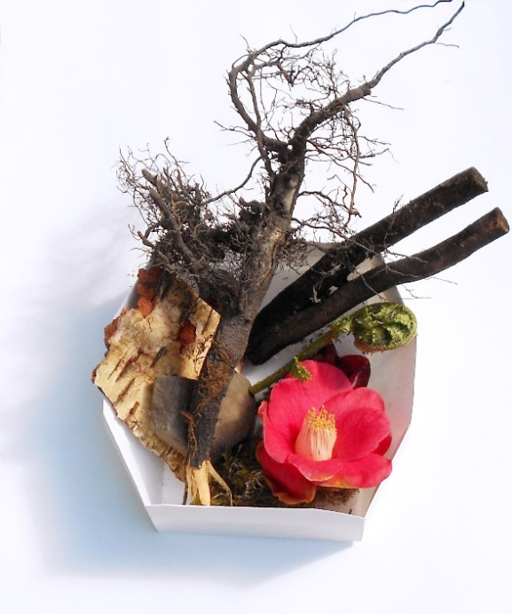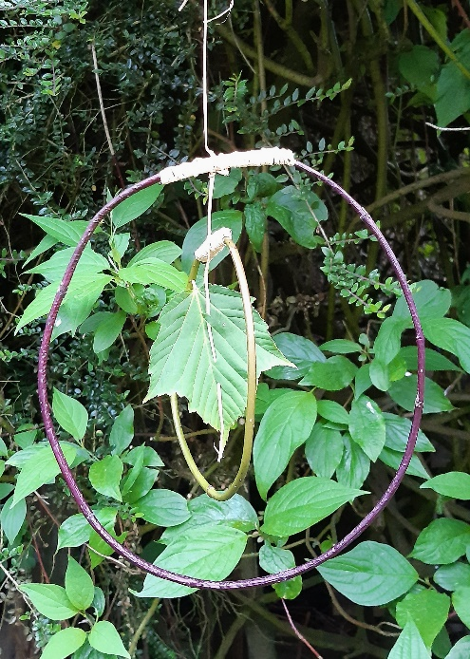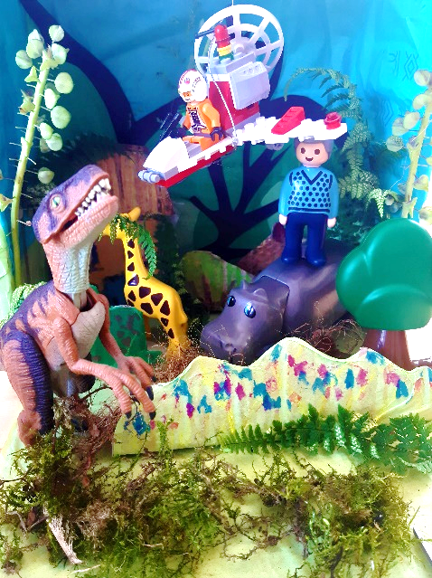

There are four strands of activity for each summer school, which you can navigate how you wish over the summer. Four Creative tutors will lead you through an exciting series of workshops, demonstrations and resources, to develop your creative practice at whatever stage you may be at. Please note you will require an internet connection to take part in this activity on either a computer/laptop or smartphone.
The videos will guide you through a different creative theme in our four strands of Arts activities. You will be able to stop and start the video, then you can make along with the video or after watching the demonstration. There are also handouts available which can be downloaded, that you can view on a phone or a computer.

The ‘Let’s be Creative’ Summer Arts Schools are a widening participation initiative that is part of Leeds Arts University’s Access and Participation Plan, approved by the Office for Students (OfS). The course is very popular and numbers are limited, therefore applications are considered on an individual basis. Applicants from under-represented backgrounds or who live in an area of low participation in higher education will be prioritised.

Please email your completed form to progression@leeds-art.ac.uk
by Monday July 19th 2021 5pm

We will email you whether or not you have a place on the course and provide further information.
The Summer Schools will then be emailed as a link on Friday 23rd July.

