AET Making Sense of Autism - STARS resource pack for primary and secondary – part 2
Building relationships:
Circles of Intimacy: | How to write Social Stories:  Very simple social story example  More complex social story example | Developing baseline communication skills  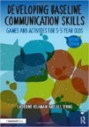 | Talkabout for children  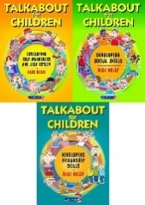  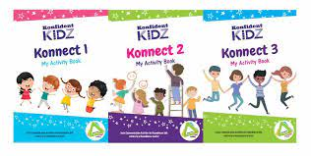 | Konfident Kidz – social skills activity books

Enabling environments:
STARS colourful sensory profile | Mindmate – stress pot  Stresspot (mindmate.org.uk) | How Am I feeling Plan | How to make an emotional rating scale  Emotional Rating Scale – example | The Zones of Regulation:  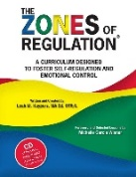  Reframe the behaviour

Curriculum and learning:
STARS Transition Book | Leicestershire Primary Differentiation Pack  Strategies for accessing the curriculum KS3 & KS4:  https://webarchive.nationalarchives.gov.uk/20110113113522/http://www.teachernet.gov.uk/wholeschool/sen/teacherlearningassistant/ASDKS34/ | Visual Cue Cards  ‘I am working for’ – Work Contract | Tools for teachers work scaffold:  Tools for teachers – group roles: | Structuring work activities - various  9 reasons to use visuals

