Music Connect

Leading The Way in CPD

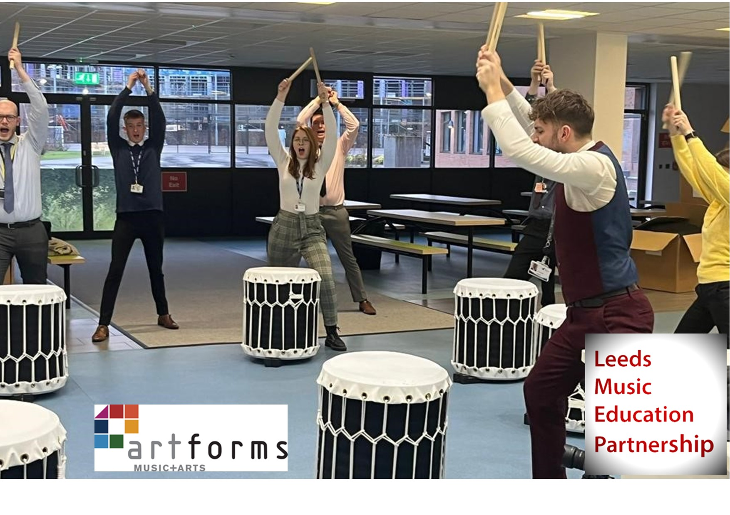

2023-24 Programme

Music Connect provides a programme of network groups, CPD and events designed specifically for Music leaders and non-specialist teachers. It was created specifically to support all schools in Leeds in delivering high quality Music education. Music Connect is delivered by ArtForms who are always available for any queries regarding your school Music curriculum. We work with schools through all stages of curriculum development with the aim of facilitating all pupils to reach their musical potential.

Music Connect receives funding from LMEP, the Leeds Music Education Partnership, which enables ArtForms, the lead partner, to offer the programme to Leeds Schools and Academies at no charge.

During the academic year 2023-24, the programme comprises:

- Professional development opportunities for teachers and supporting staff, delivered by music specialists
- Network meetings to support Primary Music Leaders
- Network meetings to support Secondary Music Leaders
- Updates of national, regional and local developments in Music
- Bespoke advice and guidance sessions in your school (1 hour per school per year, extra time can be purchased). This meeting will usually take place with the Music Leader or SLT. Unfortunately it cannot be used as a Staff Training session
- Access to Charanga, Sing Up, or Sparkyard from Out of the Ark which are online music resources designed to support non-specialists to deliver the music curriculum
- Priority access to additional Music Connect events
- Priority access to instrument hire linked to CPD training
- Centrally developed resources designed to support the delivery of the Music Curriculum

Schools are permitted to send up to two delegates to each of the sessions from the calendar, subject to availability.

All training sessions are subject to change and will be regularly updated.

Unless otherwise stated, please book your chosen sessions via www.LeedsforLearning.co.uk

In-school training is chargeable at £210 per session for up to 1.5 hours.

Schools and colleagues outside of Leeds are charged at the following rates:
Twilight sessions: £85
Half day sessions: £130

In the event of cancellation by the school, ArtForms reserves the right to collect fees according to the following guidelines: 5 days or more before delivery is scheduled - the fee is waived; 4 days or less before delivery is scheduled – 100% of full fee. This is applicable to all institutions regardless of subsidy.

For further information, please contact
Sam Mercer, Music Curriculum Support Manager
Sam.Mercer@leeds.gov.uk

Music Connect Training and Events

 |  |  | Training | Session details
AUTUMN TERM 2023 |  | October | Secondary Music Subject Leader Development Meeting  This year for the first time, the LLP’s Secondary Music Leaders Development Meeting and the LMEP Secondary Music Leaders Network led by ArtForms are joining together so that all Heads of Music in Leeds secondaries can access the two networks in one go. This is the first of three sessions offering curriculum support, practical music-making and sharing best practice. All Secondary Music Leaders are very welcome! | Date: 9th October 2023  Day: Monday  Time: 9:00am-3:00pm  Venue: Benton Park School  Course Code: SMLDM1
 |  | November | Primary Music Leaders Network Session 1  The first of three sessions offering curriculum support, practical music-making and sharing best practice. All Primary Music Leaders are very welcome! | Date: 8th November 2023  Day: Wednesday  Time: 4:00-5:15pm  Venue: Zoom  Course Code: PMLN1

 |  | Training | Session details
SPRING TERM 2024 | February | Sue Nicholls - A Fresh Look at Composition  The brilliant Sue Nicholls is back in a face to face session at Pudsey Civic Hall. Sue has worked as a music subject leader in many primary settings during her career as a teacher. She has published several music resource books for non-specialist music teachers. Sue now works as an independent music education consultant leading workshops and courses for schools and music hubs. This course is designed to give teachers ideas about how to teach composition. You will leave with lots of new resources, songs and materials. All while having fun, learning with Sue. | Date: 7th February 2024  Day: Wednesday  Time: 2:30-4:30pm  Venue: Pudsey Civic Hall  Sign up here via Leeds for Learning  Or search on LfL for COMP
 |  | Primary Music Leaders Network Session 2  The second of three sessions offering curriculum support, practical music-making and sharing best practice. All Primary Music Leaders are very welcome! | Date: 26th February 2024  Day: Monday  Time: 4:00-5:15pm  Venue: Microsoft Teams  Course code: PMLN2
 | March | Secondary Music Subject Leader Development Meeting 2  The second of three LLP/LMEP combined network sessions offering curriculum support, practical music-making and sharing best practice. All Secondary Music Leaders are very welcome! During this session we will meet with other Subject Leaders from across the city to share national and local up-dates. | Date: 19th March 2024  Day: Tuesday  Time: 9:00am-3:00pm  Venue: TBC  Course code: SMLN2
 |  | KS1 Little Sing:  An immersive Musical Experience for KS1 children featuring a live band and lots of interactive musical activities. Last year we went on a boat journey to a tropical island full of bananas and explored under the sea on the way. Come along and see where our adventure takes us this year. The children will love our session of singing and moving – and it’s a great CPD session for staff too! | Date: 22nd March 2024  Day: Friday  Time: Two sessions -  10:00-11:00 and 1:00-2:00  Venue: Pudsey Civic Hall  Book via: sam.mercer@leeds.gov.uk

See next page for events in the summer term.
 |  | Training | Session detail
Summer Term 2024 | April | Sue Nicholls - Developing As A Primary Music Leader  Now that Sue is back we decided to book her twice. This session will be to examine the role and responsibilities of the Music subject leader. | Date: 17th April 2024  Day: Wednesday  Time: 4:00-5:30  Venue: Microsoft Teams  Course code: MLDEV
 | May | Primary Music Leaders Conference  After the success of last years conference attended by over 50 primary schools in Leeds we have again created the opportunity for Music Leaders to meet face to face in an extended network meeting. Speakers TBC but it would be lovely to see as many of you as can make it to enjoy the usual curriculum support, practical music-making ideas and sharing of best practice for a whole day. | Date: 17th May 2024  Day: Friday  Time: 9:00-3:30  Venue: TBC  Course code: PMLN3
 |  | Big Samba Teacher Workshop  This is our annual Samba CPD and performance event that engages children in a thrilling musical experience while training non-specialist teachers to deliver exciting Music lessons using Brazilian percussion. There will be a workshop for teachers to learn the Samba grooves on Monday 15th May at Pudsey Civic Hall. All Samba equipment is provided. The project culminates in a performance event at John Charles Centre for Sport involving schools from across Leeds. 600 children took part in this event last year. | Teacher Workshop Date:  20th May 2024  Day: Monday  Time: 4:00-5:30  Venue: Pudsey Civic Hall  Performance Date:  11th July 2024  Day: Thursday  Time: Two sessions –  10:00-11:30 or 1:00-2:30  Venue: TBC  Book via: sam.mercer@leeds.gov.uk
 | June | Secondary Music Subject Leader Development Meeting 3  The third of three LLP/LMEP combined network sessions offering curriculum support, practical music-making and sharing best practice. All Secondary Music Leaders are very welcome! During this session we will meet with other Subject Leaders from across the city to share national and local up-dates. | Date: 24th June 2024  Day: Monday  Time: 9:00-3:30  Venue: TBC  Course code: SMLN3
 | July | Big Samba Performance  The is the live performance event involving schools from across Leeds. See details above. | Date: 11th July 2024  Day: Thursday  Time: Two sessions –  10:00-11:30 or 1:00-2:30  Venue: TBC  Book via: sam.mercer@leeds.gov.uk

The Music Connect Digital Offer for Primary Schools

During the academic year 2022-23, LMEP is continuing to support Leeds Primary Schools by fully subsidising one of three digital platforms. Schools have a choice between membership to Sing Up, or a licence for either Charanga or Sparkyard from Out of the Ark.

Charanga  https://charanga.com/site/ | Sing Up!  https://www.singup.org/ | Sparkyard - Out of the Ark  https://www.sparkyard.com/
- Charanga membership provides a vast library of resources, songs, instrumental courses and creative apps.  - These include two week by week schemes of primary schools for a full year. Their latest scheme is informed by the Model Music Curriculum.  - The schemes come with lesson plans showing clear progression and interactive resources for every lesson.  - This platform provides the resources and support to enable non-specialist teachers to deliver Music lessons independently. | - Sing Up has an extensive catalogue of established and commercially successful songs expertly arranged for young voices.  - The songs come with high quality backing and performance tracks as well as sheet music and an interactive white board mode.  - Membership gives you access to all their songs as well as teaching resources and support materials including their new Sing Up Music Units for every year group.  - This is not only excellent for teaching but also to provide material and accompaniment for singing assemblies.  - The breadth of the Sing Up catalogue is a real selling point. | - Out of the Ark write their own excellent songs specifically for schools.  - The songs are designed to be both age appropriate, and, musically appropriate in terms of the level of challenge.  - Their catalogue includes bespoke songs for all areas of the curriculum, and for assemblies and school productions.  - Their new package allows members to have universal access to their entire song catalogue and also offers curriculum ideas, lesson plans and listening activities.

Each of these three packages have something different to offer to support schools.

New licences/memberships start on the 1st October 2022 and last for one year. The original deadline for schools to submit their preference was 22nd July. To maximise the number of schools who can access this opportunity we are extending this deadline.

To order the platform you wish to use for the next academic year please email LMEP.ArtForms@leeds.gov.uk by Friday 23rd September 2022.

We have a finite number of licences for each platform and they will be allocated on a first come first serve basis. Applications after this deadline will be subject to availability.

The Music Connect Digital Offer for Secondary Schools

During the academic year 2022-23, LMEP is continuing to support Leeds Secondary Schools by fully subsidising one of two digital platforms. Schools have a choice between a licence for Charanga or membership to Musical Futures Online. Here is a summary of what each platform offers -

Charanga  https://charanga.com/site/ | Musical Futures  Home | Musical Futures Online
- Charanga is a dedicated learning platform for music, enabling you to manage and share personalised projects, lessons and apps that your students can access anywhere.  - It’s newest feature is an integrated online music studio and app suite to support students’ creative work. Catering for novices and more experienced users, YuStudio, Charanga’s full-featured DAW (digital audio workstation), can be used by students in many forms of music-making.  - And online workspaces to extend teaching and learning beyond the classroom  - Charanga features interactive teaching resources to enhance your school’s music curriculum. These include everything from a complete programme for beginner wind bands to creative classroom apps and bespoke projects for special needs students. Use them independently or combine them with your own resources. | - The JustPlay resources provide whole-class music making opportunities of over 300 tracks for popular classroom instruments such as ukulele, guitar, keyboard and vocals.  - JustPlay includes full video guides to support learners starting with basic chords and rhythmic patterns working up to performing a range of songs and chord changes.  - Ideal for Whole Class Instrumental work at KS3 and 4. There are playalongs based on difficulty, music style and by theme.  - Includes a Songwriting Programme for KS3 & 4.  - Includes Music Technology resources based on Music Production, Rap, and DJ Skills.

Both of these packages have something different to offer to support schools.

To order the platform you wish to use for the next academic year please email LMEP.ArtForms@leeds.gov.uk by Friday 23rd September 2022.

We have a finite number of licences for each platform and they will be allocated on a first come first serve basis. Applications after this deadline will be subject to availability.

 |  | In-School Training | Session details
AVAILABLE THROUGHOUT THE YEAR | DATES BY NEGOTIATION | Would you like to train your whole teaching team on an aspect of music? Or maybe your Music Leader would like to have a longer consultation with one of our lead teachers? In house training is available. Each session lasts up to 1.5 hours and is led by one of our specialist advisers. Contact Lee Muncaster for further information.  The training can be bespoke to your school’s needs. Ideas might include:  Introducing your teaching team to Charanga, Sing Up or Out of the Ark’s Sparkyard.  An overview of the resource which will enable all of your team to get started.  Developing a Music Scheme of Work  Working with your Music Leader, let us help you to develop a comprehensive scheme suitable for your school  Notation for Novices  A step by step guide to teaching music notation throughout the Primary Phase. Our process starts in EYFS and continues throughout the school.  Wellbeing Sessions – Steelpan and Mixed Percussion  In these difficult times the well-being of staff, as well as that of students, is more important than ever. We are delighted to offer well-being sessions on steel pans and mixed percussion given by Victoria Jaquiss. A whole group can learn to play an easy eight bar song in 20 minutes having never played them before. | Up to 1.5 hours delivery  £200 per session  Book via  Lee.Muncaster@leeds.gov.uk

