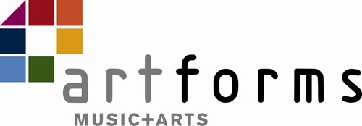
Instrumental/Vocal Music
End of Year Report 2023/24

Name:

Instrument:

This Year’s Learning and Achievement

Next Steps for Learning

Student comments and aims for next year

This is an opportunity for your child to reflect on their report and set an aim for themselves for the following school year. If they have not been able to do this during their lesson, please could they complete this at home and any comments be emailed through to educ.artforms@leeds.gov.uk.

Teacher signature: Date:

