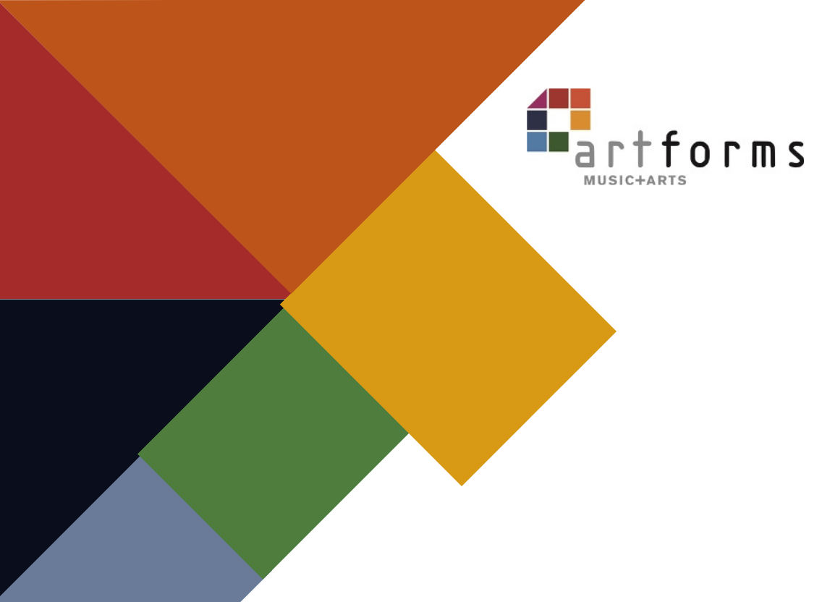

Your School’s name here

Music Development plan 2023/24

School address
99 Basic way
leeds
LS1 1sl

Headteacher:
Music Lead Teacher:

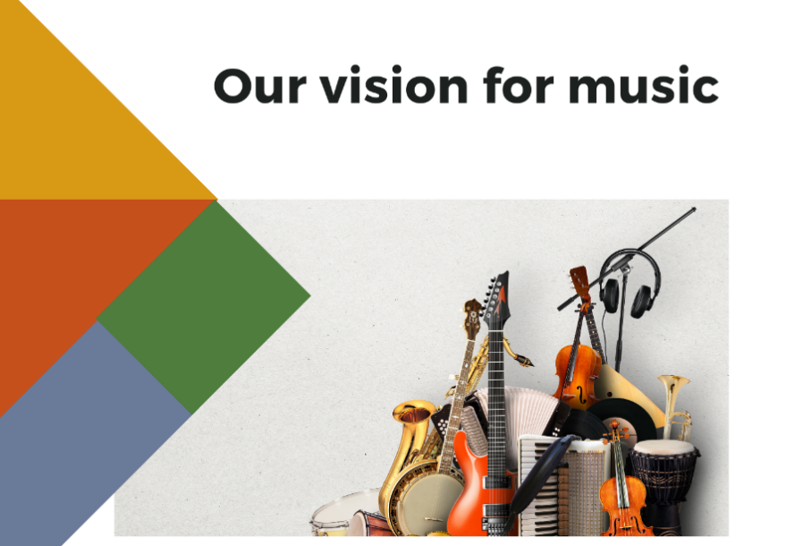

A vision statement is a useful place to start to think about your vision for music in school. It should set out your current and future objectives for music provision. What are the aims of your current provision and what are your goals to develop it further?
Insert your vision for music here. Your vision statement might include:
- Why is music important?
- What is the purpose of teaching music?
- What are your primary goals for music in your school?
- What are the pupil related outcomes of your music programme?
- What does a child's musical journey through your school look like?
- What opportunities should children have to develop their love of music?
- How does music contribute to or compliment the ethos of the school?
- How do envisage different types of music provision linking up and working together (e.g., curriculum teaching, whole class instrumental, small group tuition, singing assemblies..)

1 – Not yet in place | 2 - Emerging | 3 - Established | 4 - Embedded
Prioritise for support and development | Further development and support required. Not yet sure of impact on outcomes | Effective in producing good outcomes. Some ongoing support may be required to maintain or further improve provision | Highly effective in producing excellent outcomes.

Area | Category | Description | Comments
Curriculum Music | Timetabling | 1 - Not all classes receive a regular music lesson each week
 |  | 2 - Music lessons are scheduled but not always delivered regularly
 |  | 3 - There are weekly timetabled curriculum music lessons in all years
 |  | 4 – There are weekly timetabled curriculum music lessons in all years plus other provision which totals 1 hour per week for all children (can include singing assemblies etc)
 | Curriculum design | 1 - Musical activity takes place in some or all classes but not tied to a formal school-wide curriculum.
 |  | 2 – There is a whole school curriculum in place for music but progression over the years is not clear or well understood
 |  | 3 - There is a whole school curriculum in place for music which covers all parts of the National Curriculum. It is clear how each year builds on the previous years and lays a foundation for what the children will learn next
 |  | 4 - There is a whole school curriculum in place which clearly maps progress and skills across the key stages. Teaching staff are aware of how their year fits into the bigger picture. Additional aspects are embedded into the planning such as whole class instrumental music, school performances and special musical events
 | Assessment | 1 - No or very little formal assessment takes place in music. There is limited capacity and/or expertise for assessing musical progress
 |  | 2 – Some assessment and recording of progress is taking place in some classes. Quality of verbal feedback in lessons varies widely and further support is needed
 |  | 3 – Assessment and progress is documented in all year groups and verbal feedback in lessons is of good quality
 |  | 4 - Progress is clearly recorded using a variety of methods and ML works closely with class teachers to monitor and support quality of feedback in lessons. There are opportunities for pupils to self and peer assess their work planned into lessons
 | Quality of teaching | The teachers delivering music are mostly lacking confidence and expertise in the subject
 |  | Music teaching is of a mixed standard, there is still a need for further CPD and support.
 |  | Music teaching is mostly or all good quality throughout school.
 |  | Music teaching is consistently good quality and is regularly monitored and supported. Staff who deliver music have access to good quality CPD.
 | EYFS music | It is uncertain how much music takes place in Nursery/Reception classes or whether it is of consistently good quality
 |  | Music is regularly planned in to EYFS though some CPD and support would still be beneficial
 |  | Music teaching and singing leading is of good quality in EYFS. Regular lessons include appropriate songs and activities and the children clearly make progress
 |  | Music is an integral and essential daily part of EYFS life. Songs and activities are appropriate to developing voices and carefully chosen to support early progress
Whole class instrumental provision | Whole class | No whole class instrumental provision is currently in place
 |  | Children are given a ‘taster’ on one or more instruments in whole class lessons which is less than one year in duration
 |  | Children are given a full year to learn an instrument and as such develop basic skills and knowledge securely in that time. There are opportunities during the year for the children to perform to others
 |  | Whole class learning is fully integrated into the wider music curriculum and is deliberately placed for pupil progression. The instrument/s are also selected for progression and quality of delivery is consistently good. Some children choose to carry on with that instrument (or a related instrument) at the end of the year in whole class follow on or small group lessons.
Singing | School / KS / Year group singing | Children rarely or never sing together as part of a larger group
 |  | Children sing together occasionally at some points during the year (e.g. Christmas, Harvest)
 |  | Children sing together all or most weeks as part of a singing assembly or similar
 |  | Regular singing assemblies are led by a specialist. Singing is an important and integral part of curriculum lessons, delivered by confident teachers skilled in delivering healthy singing
 | Choirs | There are currently no school choirs taking place regularly
 |  | A school choir forms for special occasions only (e.g. Christmas, Young Voices)
 |  | There is at least one school choir which meets regularly led by a skilled teacher
 |  | There are one or more school choirs, led by skilled singing leaders which have opportunities to perform regularly and/or take part in wider community events
 | Performing | Children rarely or never get the opportunity to perform music
 |  | Children in school perform to others on an occasional basis, at least once per year
 |  | All children take part in musical performances within school on a regular basis to a variety of audiences
 |  | All children in school take part in musical performances at least once per term to a variety of audiences both within school and in the wider community / other schools.
Instrumental and vocal lessons | Tuition | There are currently no opportunities for children to learn to play an instrument in school
 |  | Children have the opportunity to learn an instrument in at least one family of instruments. There are occasional opportunities for children to perform on their instruments
 |  | Children have the opportunity to learn to play an instrument in two or more musical families (e.g. woodwind and guitar) There is a healthy uptake each year of students wanting to learn to play
 |  | There are opportunities for children to learn an instrument in various instrumental families with regular opportunities to perform to others. School regularly engages and plans with their instrumental tutors allowing for a consistent approach to music provision
 | Whole class follow on | There is currently no whole class instrumental teaching taking place in school
 |  | There are currently no opportunities for children to continue learning an instrument they have started in whole class teaching
 |  | There are opportunities for children to continue learning the instrument (or a closely related instrument) after whole class lessons have finished.
 |  | There are opportunities for children to continue learning the instrument (or a closely related instrument) after whole class lessons have finished and a good number of children choose to do this, progressing on to small group lessons.
 | Ensembles | There are currently no instrumental ensembles in school
 |  | Children learning some instruments are encouraged to join ensembles and signposted to music centres or CLYM groups
 |  | There is a school ensemble which allows some children to play together regularly in a group
 |  | Any child learning any instrument in school has the chance to play that instrument in an ensemble. There are regular performing opportunities with the group. Routes of progression for children including music centres and CLYM are signposted as appropriate
Inclusion | Inclusion | There are no provisions in place to support less affluent families. There is little adaptation in music lessons for children with additional needs or varying ability and there are limited opportunities to experience the music of different cultures
 |  | There is some provision in curriculum music lessons for children with additional needs or disabilities. Occasional opportunities to experience music from different cultures and traditions
School applies for LMEP bursaries or finds other ways to support children from low income backgrounds to learn an instrument.
Curriculum and instrumental lessons are planned to cater for children with varying needs and abilities. Pupils have opportunities to listen to and engage with music from different cultures and traditions

All staff (including visiting staff) are fully aware of any relevant additional needs in their classes. Lessons are well differentiated to cover all needs and abilities. Children are sensitively guided to learning an appropriate instrument for their specific needs
Pupils have opportunities to listen to and engage with music from a wide variety of different cultures, traditions and eras

Wider involvement | Hub participation | The school generally don’t engage with ArtForms or the local Music Hub or other partner organisations in music
 |  | The school engages with the Music Hub, ArtForms or other partner with occasional participation in local events
 |  | There is a good level of engagement with the Music Hub / ArtForms and Music Connect with annual participation in local events
 |  | The school has strong partnerships with the local Music Hub, ArtForms, Music Connect and/or other organisations with regular participation in multiple local events and concerts
 | Leadership and CPD | School has a named Music Lead but ML has little capacity to manage their subject area. There is little understanding of or support for music from school Leadership or governing body. There is little capacity within school for the music lead or other staff to engage with music CPD
 |  | ML has some capacity to manage the subject area but doesn’t have the flexibility to be able to monitor the delivery of the curriculum across school. School leadership and Governors have some understanding of the place of Music in the curriculum. Music lead has occasional opportunities to access CPD but this doesn’t get passed on to the wider staff team.
 |  | ML has a good knowledge of the subject area and is given sufficient time to oversee the delivery of music across the school. School leaders and Governors recognise the value of music and all that it contributes to the cultural life of the school. Music Lead regularly accesses specialist CPD and has opportunities to pass this on to other staff in school
 |  | ML has a thorough knowledge of the subject and supports the delivery of music in school through CPD, observations and other means of staff support. School leadership and Governors ensure that music is at the heart of the school’s day to day life. Music Lead and other staff in school access CPD in music. Music Lead has a good understanding of where gaps lie in staff knowledge and works to address those over time
 | Links with other schools | There are currently no musical links with other schools
 |  | Occasional links are made with other local schools for musical events or activities
 |  | Some links are made with peer schools, other MAT schools, religious school networks or cluster networks. Occasional musical events may take place within these communities or resources and expertise are shared. There are some transition arrangements in music with the local secondary schools
 |  | Strong links are made with other schools with opportunities to share resources, expertise and to organise events. There are strong links made to local secondary schools for Y6 transition.
 | Live music | There are currently no opportunities for children to experience and enjoy live music
 |  | There are occasional opportunities for some children to experience live music either on a trip or from visiting musicians
 |  | All children have opportunity to experience live music over the course of the school year.
 |  | All children have the opportunity to experience live music from a range of musicians which reflects the diversity of music in our world. Live music is integrated into the school’s curriculum with wider opportunities to explore the genres

MUSIC DEVELOPMENT PLAN
Overall objectives | Set out the overall objectives for your school’s music plan
Key components | List the key components that will make up the music provision in your school. The list below is an example and should be adapted for your school.  Music curriculum, including use of music technology – EYFS, KS1, KS2, SEND  Classroom instrumental teaching  Progression from classroom instrumental teaching  Visiting music teachers  Links with external music organisations  Pupil Premium student engagement  Music CPD  Choirs/ensembles  Whole school singing assemblies  Performance opportunities  Musical engagement with feeder secondary schools  Additional funding from hub/charities/fundraising
Communications | Include information about how you’ll keep parents updated via the school website; how a leaflet might be produced to inform parents about the whole school music offering; how social media might be used etc
Budget, materials and staffing | Include details of budget for curriculum music staff, instrumental teaching, LMEP bursaries, pupil premium spending, enrichment activities, instruments and resources, and subscriptions. What resources do you need to purchase? Consider how PPA time might be used. Plan CPD.

Key Areas development plan
Target | Area for development | Actions | Date to be completed by | Evaluation

