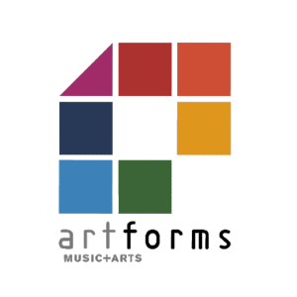
ArtForms bursary funding application form for schools 2024-25
For the academic year September 2024 to July 2025.

Apply by October half term. Maintained schools will be paid in the Spring term (by February half term), and Academies will be paid in the summer term.

Name of school
Contact email
school phone number
School cost centre number
Academy bank account details

Name of student | Date of birth | Year group | Instrument | Amount charged by school to families for the school year | (office use)  Bursary amount

I confirm that the named pupils are entitled to receive free school meals via Pupils Premium, and that they are receiving weekly small group instrumental or vocal tuition.

Signature: | Date:

Please email this form to educ.Artforms@leed.gov.uk and retain a copy for your records.

