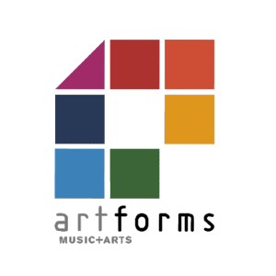
ArtForms cashback funding application form for schools 2024-25
For the academic year September 2024 to July 2025.

Apply by October half term. Maintained schools will be paid in the Spring term (by February half term), and Academies will be paid in the summer term.

Name of school
Contact email
school phone number
School cost centre number
Academy bank account details

Please tick the subsidies you are applying for:
Cashback Subsidy
Whole class instrumental teaching cashback @ 50%
100% cashback for instrument hire for whole class instrumental
Whole class instrumental follow-on @ 30%
Whole class vocal teaching cashback @ 50%
Large group instrumental teaching cashback @ 20%
Small group instrumental or vocal teaching cashback @ 20%
National Curriculum teaching cashback @ 20%
Ensemble, group or choir direction cashback @ 20%
SEND whole class @ 50%
SEND small group @20%
Music therapy @50%

I have read and agree to the Terms and Conditions in Section E of the LMEP Offer to Schools.

Signature: | Date:

Please email this form to educ.Artforms@leed.gov.uk and retain a copy for your records.

