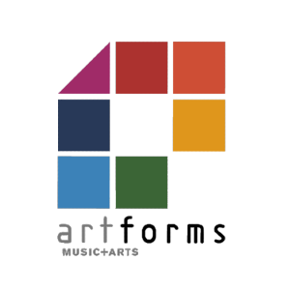
ArtForms cashback funding application form for schools 2026- 27
For the academic year September 2026 to July 2027.

Apply by October half term. Maintained schools will be paid in the Spring term (by February half term), and Academies will be paid in the summer term.

Name of school
Contact email
School phone number
School cost centre number
Academy bank account details

Please tick the subsidies you are applying for:
Cashback Subsidy
100% cashback for instrument hire for whole class instrumental
Whole class instrumental cashback bespoke model @ 20%
Whole class instrumental cashback progression model @ 40%
Large group instrumental teaching cashback @ 20%
Small group instrumental or vocal teaching cashback @ 20%
National Curriculum teaching cashback @ 20%
Ensemble, group or choir direction cashback @ 20%
SEND class teaching @ 30%
SEND small group @20%
Music therapy @ 30%

I have read and agree to the Terms and Conditions in Section D of the ArtForms Offer to Schools.

Signature: | Date:

Please email this form to wymh.artforms@leeds.gov.uk and retain a copy for your records.

